NATIONAL UNIVERSITY OF MODERN LANGUAGE ISLAMABAD
Lab 01


Submitted to:
Ms. Fatima Gillani
Submitted by:
Zulqarnain Hassan
Roll No: …………………… SP21379
Subject: …………………… SCD
Department: ……………… BSSE-5-Afternoon
Date: ……………………… 17-09-2024

TASK 01
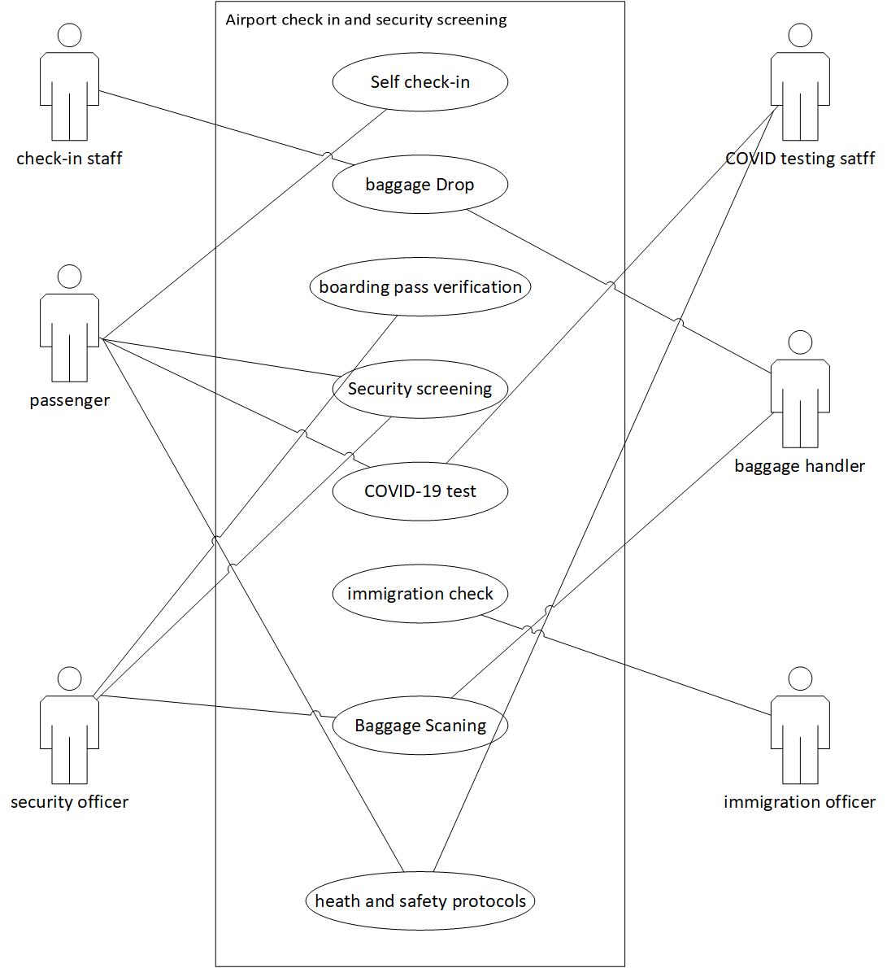

TASK 02
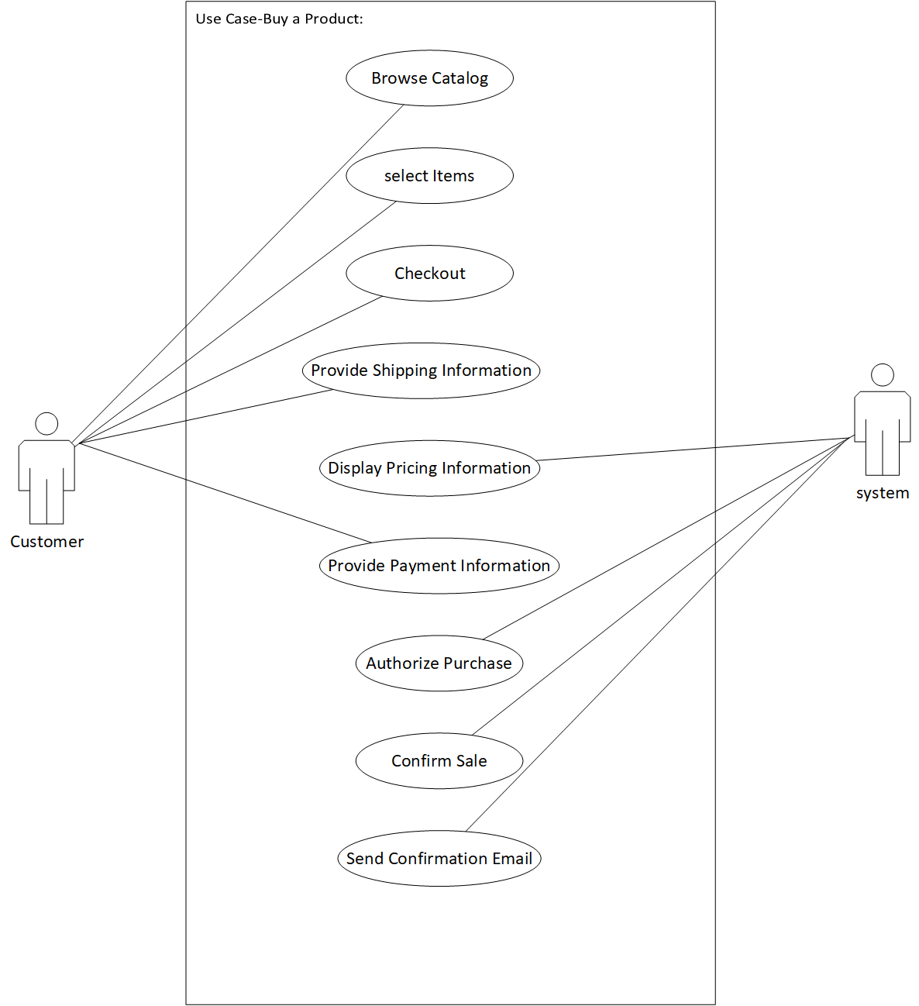

Use case ID: | 01
Use case name: | Browse catalog
Actor: | Customer
Description: | The customer opens the product catalog on the website or app and browses through the available items. The catalog may include categories, filters, search options, and detailed product descriptions.
Basic flow: | • The customer navigates to the website’s product catalog page.  • The system displays a list of products with filters and categories.
Alternate flow: | • The customer uses the search function to quickly find specific products.  • The catalog is unavailable due to technical issues, and the system displays an error message.
Pre-condition: | The customer is logged into the system or browsing as a guest.
Post condition: | The customer is presented with a list of products and may proceed to select items.

Detail description:

Use case ID | 02
Use case name | Select item
Actor | Customer
Basic flow: | • The customer views the product details page.  • The customer selects the desired quantity, size, or other attributes.  • The customer clicks "Add to Cart" to place the item in the shopping cart.
Alternate flow | The item is out of stock, and the system informs the customer with an option to be notified when the product is available.
Description | After browsing the catalog, the customer selects one or more products to purchase by adding them to the shopping cart. They can adjust quantities, view product details, and compare prices.
Pre-condition | The customer is browsing the catalog, and items are available for purchase.
Post-condition | The selected items are added to the customer’s cart, and the total price is updated.

Use case ID: | 03
Use case name: | Checkout
Actor: | Customer
Description: | The customer reviews the items in their cart and proceeds to complete the purchase by entering necessary details.
Basic flow: | • The customer clicks on the shopping cart icon.  • The system displays the cart summary with items, quantity, pricing, and total cost.  • The customer clicks "Proceed to Checkout" to initiate the payment process.
Alternate flow: | The customer removes or updates items in the cart before proceeding to checkout.
Pre-condition: | The customer has items in the shopping cart.
Post condition: | The system moves the customer to the shipping and payment page.

Use case ID: | 04
Use case name: | Fills in shipping information
Actor: | Customer
Description: | The customer enters their shipping address and selects the delivery method.
Basic flow: | • The system prompts the customer for a shipping address.  • The customer fills in the address fields (e.g., street, city, ZIP code).  • The system offers different delivery options (e.g., next-day, standard).
Alternate flow: | The address is invalid, and the system asks the customer to correct it.
Pre-condition: | The customer has initiated the checkout process and is ready to enter shipping information.
Post condition: | The system captures and validates the shipping information.

Use case ID: | 05
Use case name: | Authentication
Actor: | System
Description: | The system verifies and processes the customer's payment information to authorize the transaction.
Basic flow: | - The customer submits credit card or other payment details.  - The system securely transmits the payment information to the payment gateway.  - The payment gateway validates the payment method (e.g., checks funds, verifies card details).  - The system receives an authorization response.
Alternate flow: | The payment is declined, and the system notifies the customer, offering alternate payment options.
Pre-condition: | The customer has entered valid payment details.
Post condition: | The system successfully authorizes the payment, or it informs the customer of any issues.

Use case ID: | 06
Use case name: | Sends conforming email
Actor: | System
Description: | The system sends a confirmation email to the customer containing the order summary and tracking details.
Basic flow: | • The system generates a confirmation email.  • The system includes the order number, items purchased, total cost, and shipping information.  • The email is sent to the customer’s registered email address.
Alternate flow: | The email delivery fails due to incorrect email address, and the system logs an error.
Pre-condition: | The system has confirmed the sale and has access to the customer’s email address.
Post condition: | He customer receives an order confirmation email.

TASK 03
